**ASSIGN A CUSTOM DOMAIN NAME TO YOUR WEBSITE**

**What is a domain name?**

In the last unit, you deployed your site and [GitHub](https://www.codecademy.com/resources/docs/general/github) Pages assigned your site a default [URL](https://www.codecademy.com/resources/docs/general/url), or domain name.

In this unit, you’ll purchase your own custom domain name and assign it to your GitHub Pages website. At the end of the unit, you’ll be able to access your site using both your new domain name and your default GitHub Pages domain name.

Before you choose a custom domain name, it’s important to first understand what domain names actually are.

Domain names are human-friendly names that identify servers on the Internet. A global system known as the Domain Name System (DNS) is used for storing which domain names correspond to which servers.

For example, Codecademy’s domain name is www.codecademy.com. When you type the domain name into your browser, your computer asks the [DNS](https://www.codecademy.com/resources/docs/general/dns) to identify which servers should receive the request in order to load our website.

**Note:** This unit is optional. We’ll walk you through the steps required to purchase a custom domain name and assign it to your GitHub Pages site. If you do not want to purchase a domain name, you won’t have to. However, feel free to follow along to see what steps are required to do so (for future reference).

**Instructions**

Observe the diagram to the right.

In the top portion of the diagram:

1. Bob wants to call Sue, but does not have Sue’s phone number memorized.
2. Bob types “Sue” into his phone and his phone identifies the phone number associated with Sue.
3. The phone call is then made. Sue’s phone receives a request (it rings). If Sue answers, Bob and Sue are connected and can now communicate.

Your computer communicates with websites in a simliar fashion.

In the bottom portion of the diagram:

1. Bob wants to load the Codecademy website, but does not have Codecademy’s IP address memorized.
2. Bob types www.codecademy.com into his browser and the DNS then identifies the IP address associated with www.codecademy.com.
3. The request to load Codecademy’s website is then made. If the server successfully responds, Bob can now load and communicate with Codecademy’s website.

For more details, read the following Codecademy resource:

1. [HTTP Requests](https://www.codecademy.com/articles/http-requests)

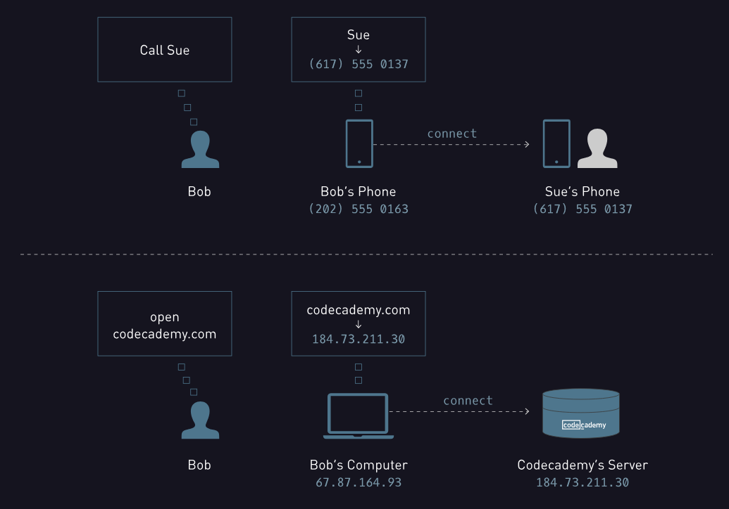

### Custom Domain I

Often, the most time consuming part of buying a domain name is actually deciding what you’d like it to be. Be aware that not all domain names are available; many have already been claimed by others.

We’re going to use [Amazon Web Services (AWS)](https://aws.amazon.com/) to purchase your custom domain.

AWS is an industry standard suite of web infrastructure services used frequently by developers. The specific service we’re going to use to purchase your domain name is called Route 53.

### Instructions

If you don’t already have an account, create one at [https://aws.amazon.com](https://aws.amazon.com/).

AWS uses a thorough verification process. You’ll have to confirm the following:

1. Contact information
2. Payment information (no purchase is necessary to open an account, but a debit or credit card is)
3. Identity verification (a PIN entered via a phone call)
4. Support Plan (there is a free plan)

Remember, creating an AWS account is free — there are no required purchases. The only purchase that you’ll (optionally) make will be the purchase of your custom domain name.

### Custom Domain II

AWS offers many services used for web development like servers, databases, and networking configuration. If you’re new to using AWS it’s easy to feel overwhelmed at first by all that it can offer, but we’ll walk through the exact steps needed to create a custom domain name.

After logging into your account, you’ll land on the AWS console. The console displays the many different services we mentioned earlier.

In this lesson we’re going to focus on a service called “Route 53,” under the “Networking” category. Route 53 can be used to purchase domain names and create [DNS](https://www.codecademy.com/resources/docs/general/dns) records.

### Instructions

1. Log into your AWS account.
2. In the AWS console, click on “Route 53” located under the “Networking” title.
3. On the next page, click on the “Get Started Now” button under the “Domain Registration” section.
4. On the next page, locate the two buttons at the top of the page. Click on the button titled “Register Domain.”

### Custom Domain III

Now it’s time to select a domain name and make sure it’s available.

Route 53 allows you to search the availability of a domain name you have in mind. It also offers many suffixes, like .com, .io, .me, and .pizza. If the domain name you want is unavailable as a .com for example, you can try using a different suffix.

The suffixes of domain names are known as top-level domains (TLDs). Different TLDs cost different annual prices.

**Note:** .com domains are the most popular and are therefore generally unavailable (or expensive).

### Instructions

1. In the text field, type in a domain name you have in mind. Do not type in www. before the domain name.

For example, if you wanted to try purchasing our domain name, you would type in codecademy and select the .com TLD in the dropdown menu.

2. Once you’ve entered a domain name you like, click the button on the right labeled “Check” to see if it’s available.

3. If you’d like to purchase the domain name, select it and continue through the rest of the checkout process.

**Setting Up Your Custom Domain**

Congrats — you’re the proud owner of a custom domain name!

You might notice, however, that your new domain name doesn’t work yet — you can’t visit it in your web browser. We have to connect it to your [GitHub](https://www.codecademy.com/resources/docs/general/github) Pages website first.

There are two steps required:

1. Inform GitHub of the new domain name we’ll be using (the one you purchased)
2. Set up [DNS](https://www.codecademy.com/resources/docs/general/dns) records in Route 53 that direct to GitHub

Let’s start with the first step.

**Instructions**

1. Open [GitHub](https://github.com/) and access the repo you created earlier titled your-user-name.github.io.
2. Click the “New file” button.
3. Name the new file CNAME. Do not add a file name extension.
4. In the file, on line 1, type the custom domain name you just purchased in the following format:

yourcustomdomain.com

You may have purchased a domain name with a TLD other than .com. In that case, make sure to use that TLD when creating the CNAME file.

5. Commit the new file.

6. Under the title of the repo, click on “Settings.” Scroll down to the section titled “GitHub Pages” and confirm that there is a message *similar* to the following:

Your site is published at http://yourcustomdomain.com.

7. Try navigating to your website in your browser using your new domain name. It still doesn’t work! Let’s finish setting it up in the next few exercises.